**Concept of Basic Authentication:**

Use REST backend to valid the user and password

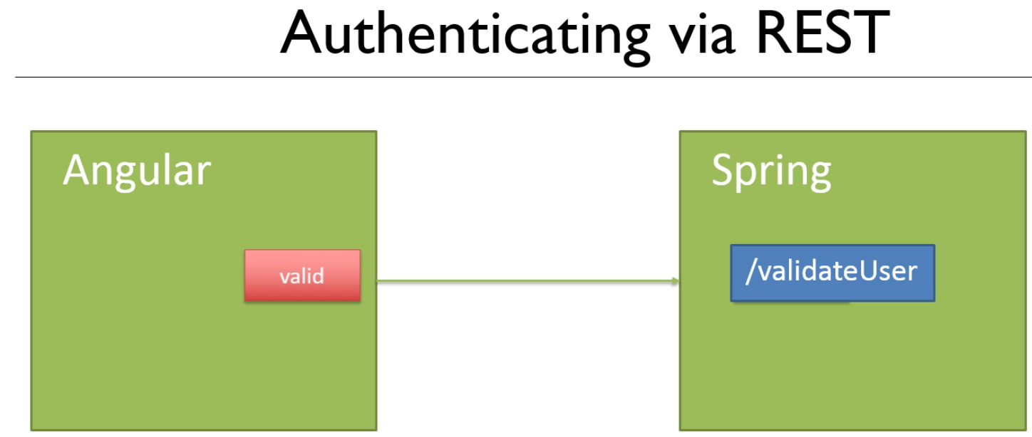

Access is provided by Authentication, which roles enable authorization:

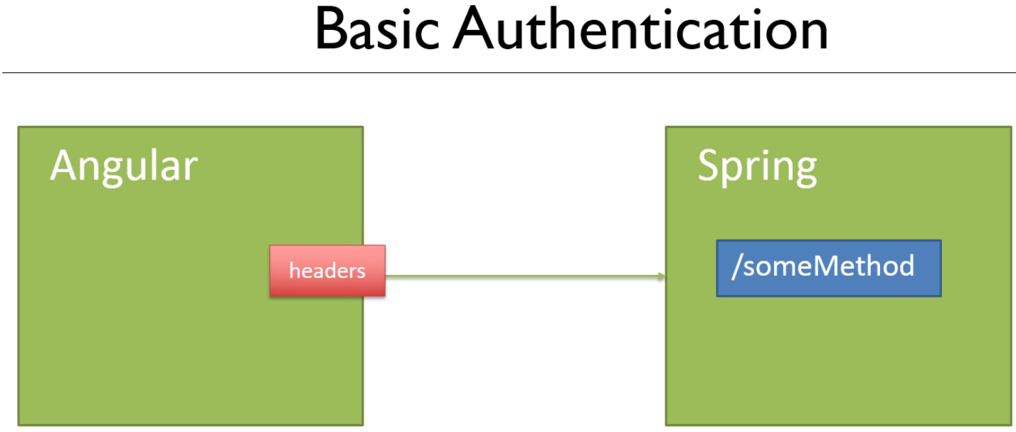

Credentials are sent in the header in a particular format

The results are then sent back from the REST spring method

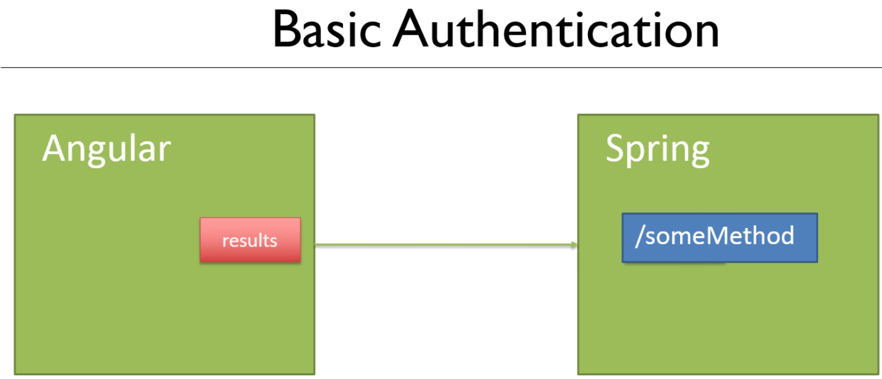

The format is as follows:



With base64 encoding it looks like this:



Secure this by using SSL

Next, let us create a REST method called validateUser()

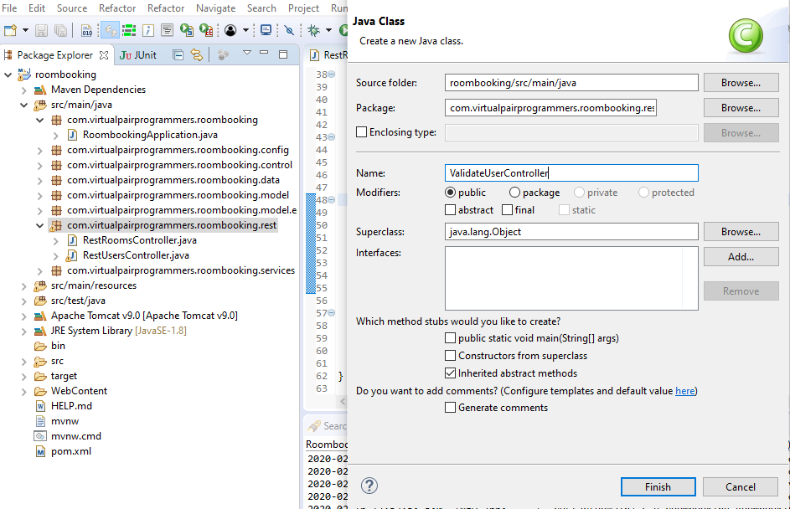

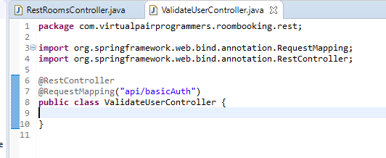

This fires only is the login is valid, else a 401 error will return

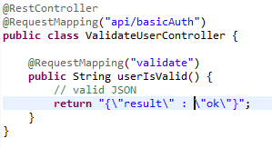

Now, add a spring dependency

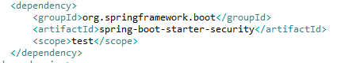

To fetch the dependency in eclipse

Use a maven build on the pom.xml file

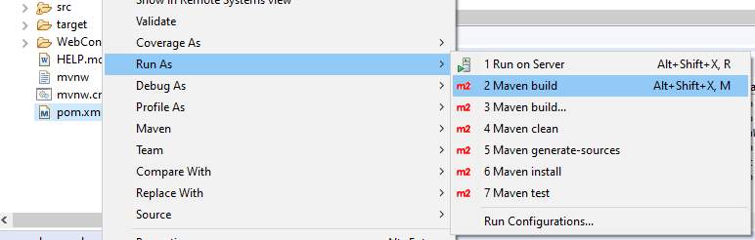

Fill in the Goal: eclipse:eclipse

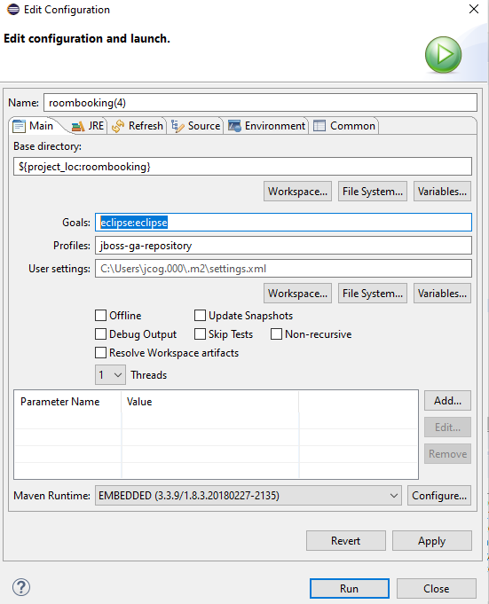

Select Run

Various jars are downloaded and the app rebuilds:

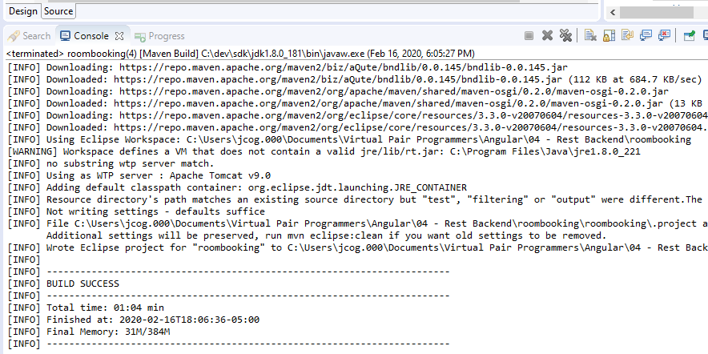

Create a new class in the config package

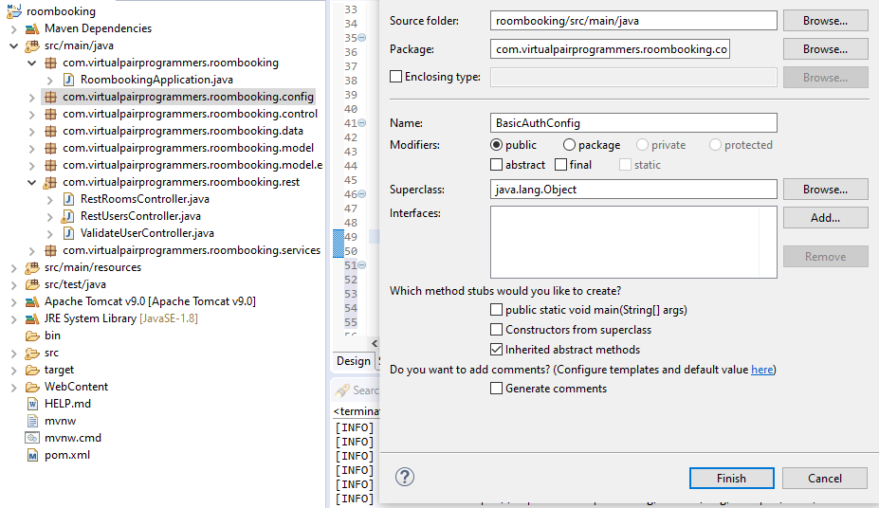

Authentication type class

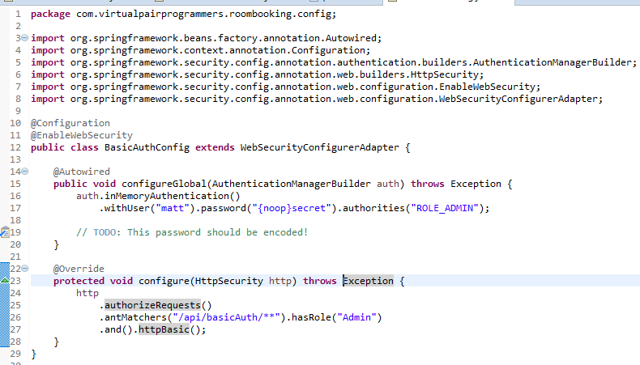

Testing Basic Authentication: use curl

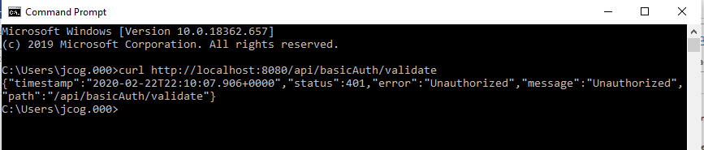

Now use a Header with –H “” with base64 authentication

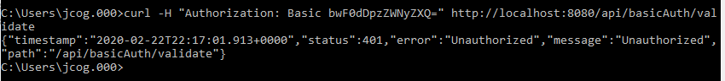

Got an Error, so let us fix the error

uthorization:

Basic bWF0dDpzZWNyZXQ=

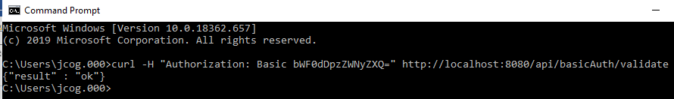

Notice the capital O was a zero, lowercase w was actually Capitalized

Make sure you Save, Maven Force Update, and run as Application to renew the changes in the server:

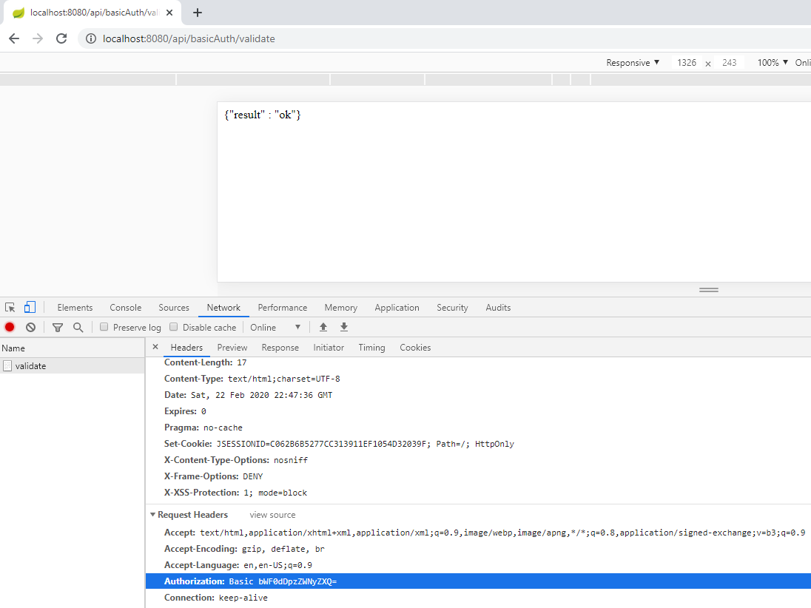

Implement the Basic Authentication in Angular:

Let us call the back end in a secure way:

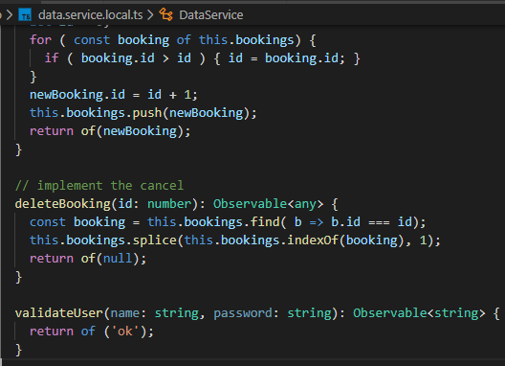

Now, implement data.service.ts file version:

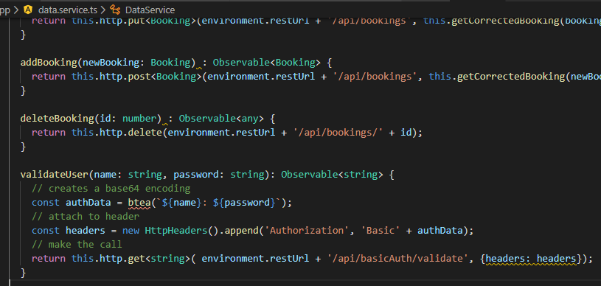

Error: btea is really btoa

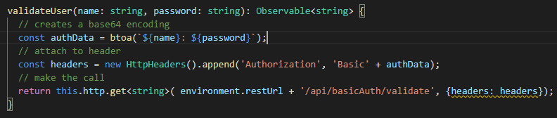

Change the auth service to use the above function

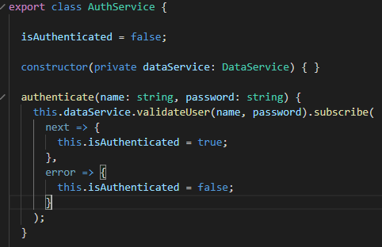

Now, switch to events

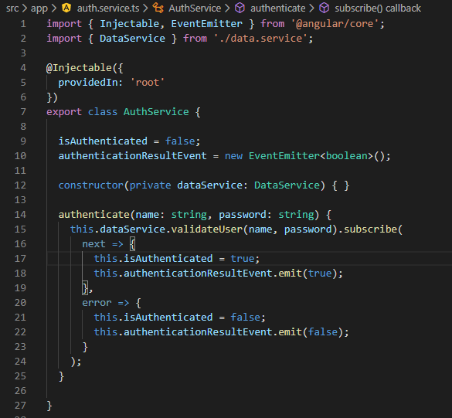

Now we calling from the login.component.ts file

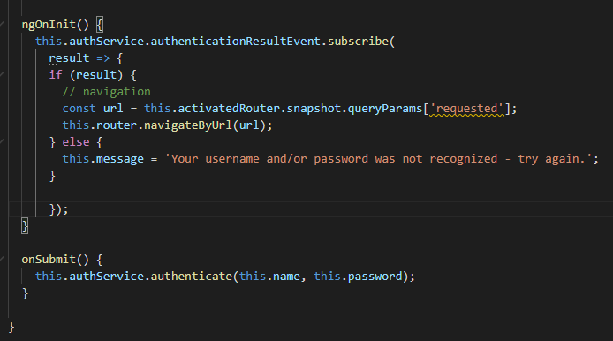

Create the unsubscription:

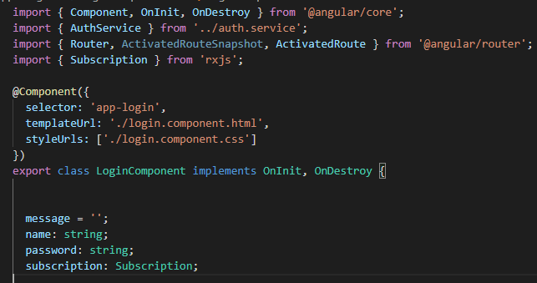

Implement the OnDestroy() and add the subscription property

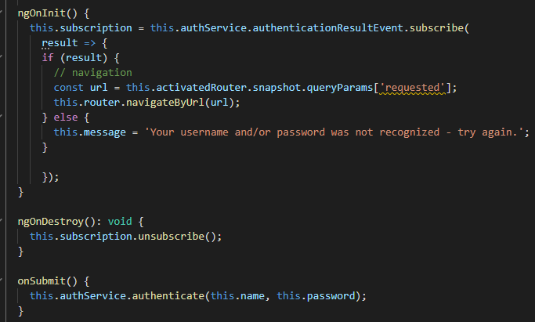

Let try it

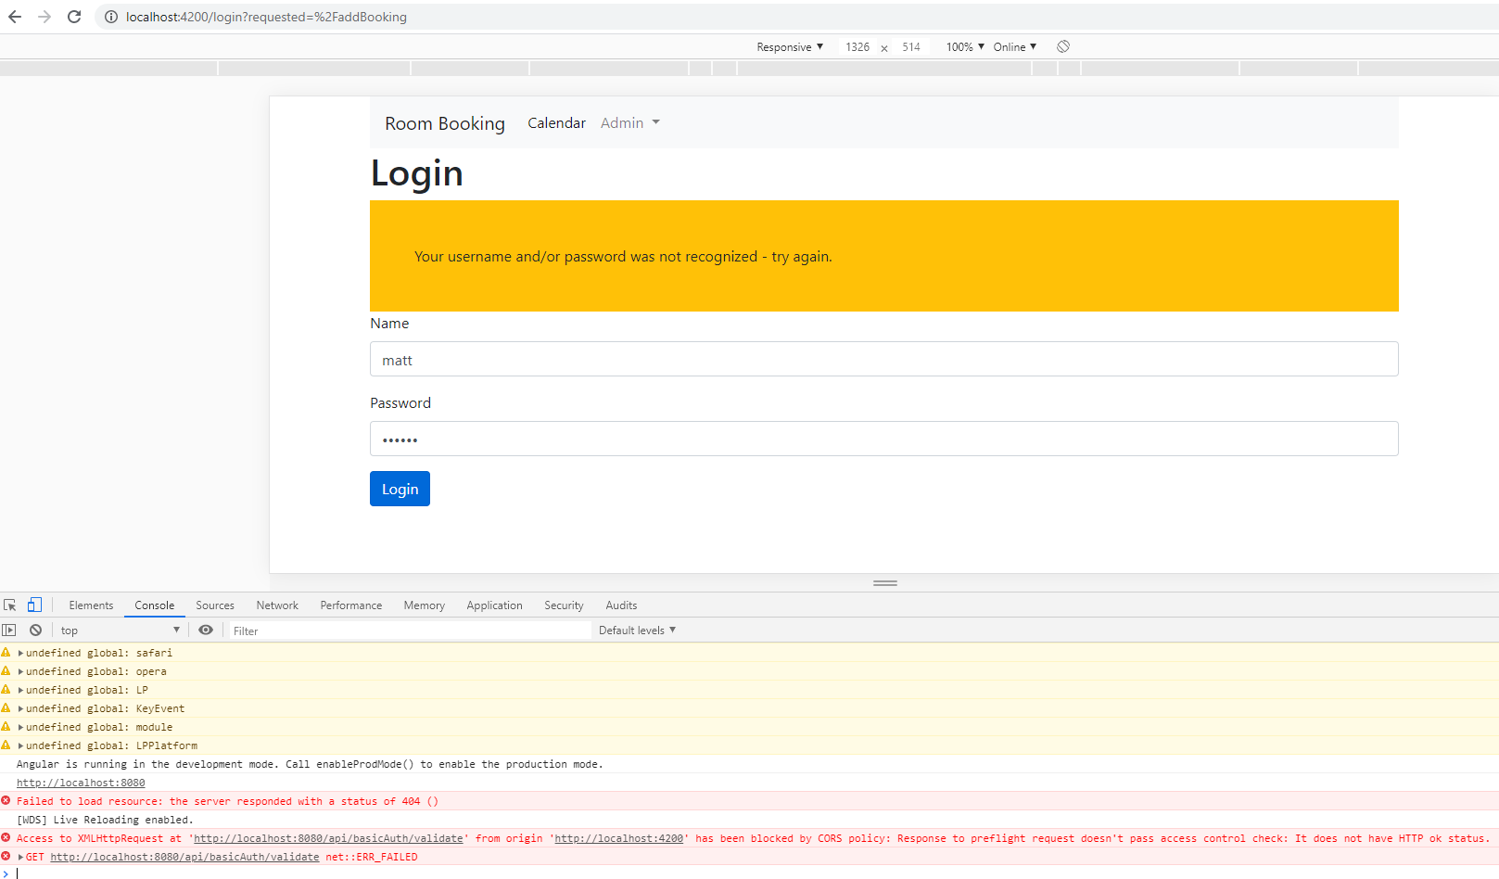

We have a CORS error:

We need to add the OPTIONS method to the CORS mappings!!

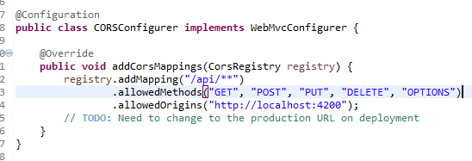

Also allow any header

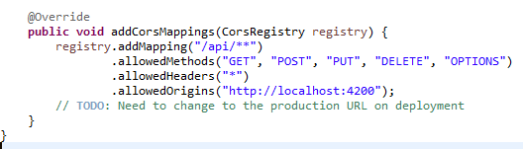

Now there is a problem that the Admin role only comes in with headers and not OPTIONS

So, we have permitAll() on OPTIONS

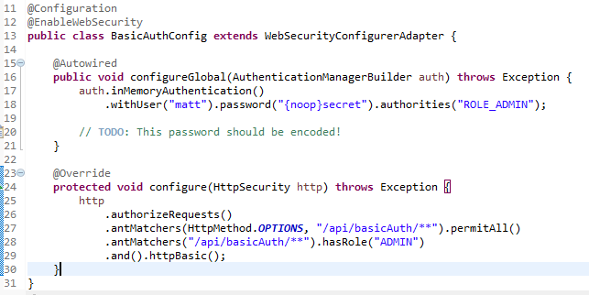

Now we have a new error



Refresh the browser and try again

No space between the matt:secret

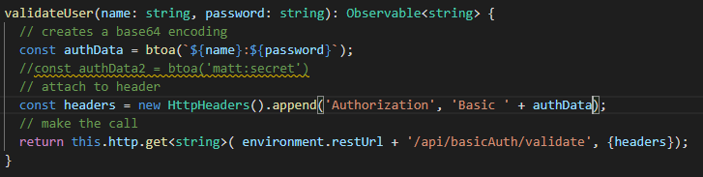

It worked

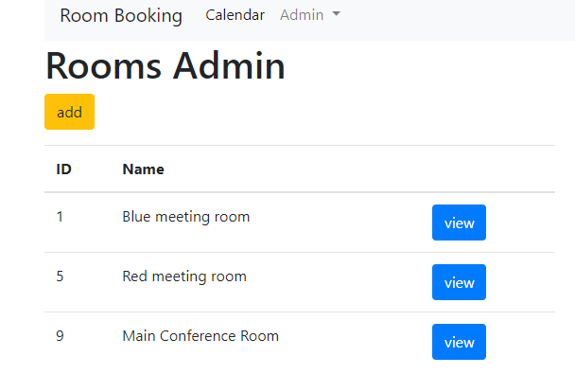

Next we will use JSON WEB TOKENS